Homework #8

1.

* First Bulletin

UPDATE tblOrder

SET OrderDate = '1/15/2016'

WHERE OrderID = 567123

SELECT OrderID,

CONVERT(VARCHAR,OrderDate, 107) 'OrderDate'

FROM tblOrder

WHERE orderid = 567123

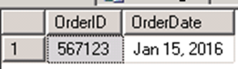

* Second Bulletin

UPDATE tblOrder

SET OrderDate = '2/10/2016'

WHERE OrderID = 671100

SELECT OrderID,

CONVERT(VARCHAR,OrderDate, 107) 'OrderDate'

FROM tblOrder

WHERE orderid = 671100



* Third Bulletin

UPDATE TblShipLine

SET MethodShipped = LOWER(MethodShipped)

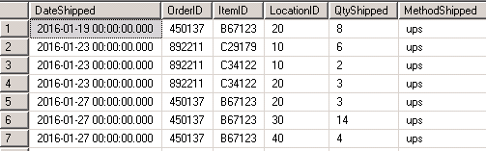



* Fourth Bulletin

UPDATE TblCustomer

SET State = UPPER(State)

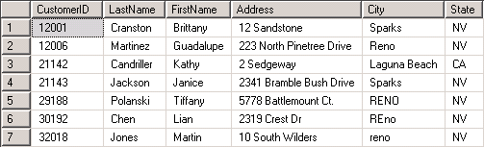



* Fifth Bulletin